**Grow Your Own Crystals**

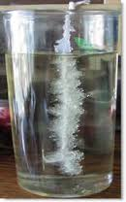

Name:

Date:

Tutor:

***What are you going to do today:***

1. Find out what is crystal;

2. Grow crystals with your friend;

3. Write a plan of your experiment.

***What are you going to do on Monday:***

* Analyse the result of your experiment.
* Draw and make a picture of Epsom salt crystals.

**What I expect to see at the end of the lesson:**

**1. Accurate and correct instructions of your experiment;**

**2. Epsom salt growth installation.**

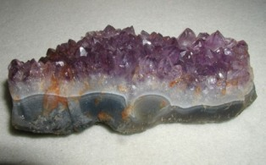**What are crystals?**   
  
**Crystals** are a special kind of solid material where the molecules fit together in a repeating pattern. This pattern causes the material to form all sorts of unique shapes.

Amethyst Crystal

**How do they form?**   
  
The process of crystal forming is called *crystallisation*. Crystals often form in nature when liquids cool and start to harden. Certain molecules in the liquid gather together as they attempt to become stable. They do this in a uniform and repeating pattern that forms the crystal.   
In nature, crystals can form when liquid rock, called magma, cools. If it cools slowly, then crystals may form. Many valuable crystals such as diamonds, rubies, and emeralds form this way.   
  
**Another way crystals form is when water evaporates from a mixture. Salt crystals often form as salt water evaporates.**   
  
**What unique properties do crystals have?**   
Crystals can have very flat surfaces called facets. They can form geometric shapes such as triangles, rectangles, and squares. The shapes are a direct result of the type of molecules and atoms that make up the crystal.

1. What are crystals?

…………………………………………………………………………………………………….

…………………………………………………………………………………………………….

2. What is the name of the crystal in the picture?..........................................................................

3. What is the name of crystal forming? ………………………………………………………….

4. Tick the right boxes:

**Crystals forms:**

From a mixture when water starts to evaporate

From rocks when they cools

When liquids cools, molecules gather together

**Crystal growth experiment**

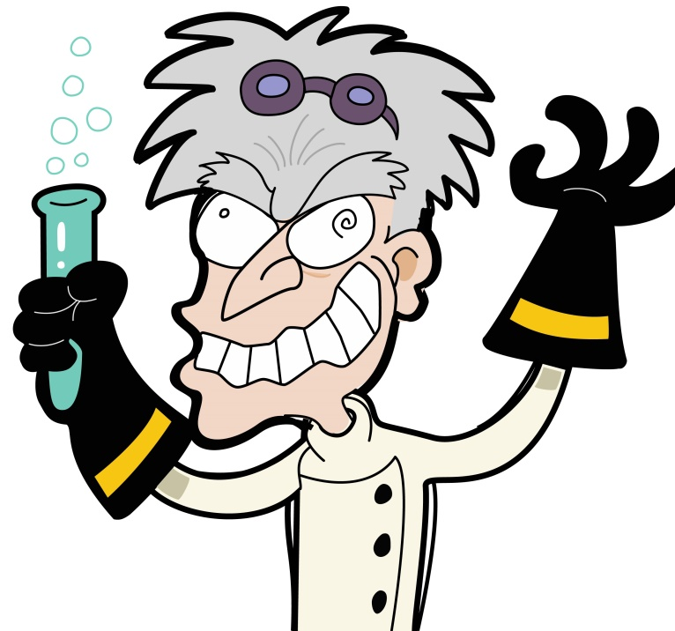

**Now, observe the demonstration and try to remember each step so you can copy that!**

Find find the person you want to work with and make your own crystal growth installation!

|  |
| --- |
| **1. Which resources you used in your experiment?** Use bullet points or numbering to divide them!  ………………………………………………………………………………………………………………  ………………………………………………………………………………………………………………  ………………………………………………………………………………………………………………  ………………………………………………………………………………………………………………  ………………………………………………………………………………………………………………  ………………………………………………………………………………………………………………  ………………………………………………………………………………………………………………  ……………………………………………………………………………………………………………… |

**2. Write instructions for your experiment step by step. Remember about handwriting, grammar. Don’t forget to divide steps by using bullet points or numbering! If it is necessary use pictures to complete this task.**

|  |
| --- |
| ………………………………………………………………………………………………………………  ………………………………………………………………………………………………………………  ………………………………………………………………………………………………………………  ………………………………………………………………………………………………………………  ………………………………………………………………………………………………………………  ………………………………………………………………………………………………………………  ………………………………………………………………………………………………………………  ………………………………………………………………………………………………………………  ………………………………………………………………………………………………………………  ………………………………………………………………………………………………………………  ………………………………………………………………………………………………………………  ………………………………………………………………………………………………………………  ………………………………………………………………………………………………………………  ………………………………………………………………………………………………………………  ………………………………………………………………………………………………………………  ………………………………………………………………………………………………………………  ………………………………………………………………………………………………………………  ………………………………………………………………………………………………………………  ………………………………………………………………………………………………………………  ………………………………………………………………………………………………………………  ………………………………………………………………………………………………………………  ………………………………………………………………………………………………………………  ………………………………………………………………………………………………………………  ………………………………………………………………………………………………………………  ………………………………………………………………………………………………………………  ………………………………………………………………………………………………………………  ………………………………………………………………………………………………………………  ………………………………………………………………………………………………………………  ………………………………………………………………………………………………………………  ………………………………………………………………………………………………………………  ………………………………………………………………………………………………………………  ………………………………………………………………………………………………………………  ………………………………………………………………………………………………………………  ………………………………………………………………………………………………………………  ………………………………………………………………………………………………………………  ………………………………………………………………………………………………………………  ……………………………………………………………………………………………………………… |

**3. Describe your crystals and draw them!**

|  |
| --- |
| ………………………………………………………………………………………………………………  ………………………………………………………………………………………………………………  ………………………………………………………………………………………………………………  ………………………………………………………………………………………………………………  http://4.bp.blogspot.com/-_iRCB3Z52Mw/TsK39AhTHeI/AAAAAAAAD7E/TW4pzEGke7M/s1600/MINCrystals.jpg |